**Practice FRQ**: Enzymes

*AP Biology*

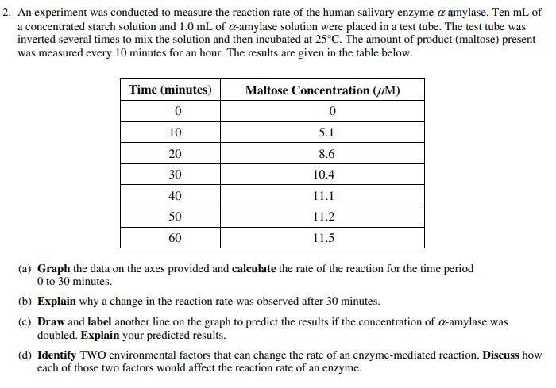

**Practice FRQ**: Enzymes

*AP Biology*

